Vehicle Detection and Monitoring

using Magnetic Sensors

Nikunj Tonthanahal Pradeep Kumar .N Nafeeya Samar Noor Zahara

[nikunj888@gmail.com](mailto:nikunj888@gmail.com) [pradeepkumar.email@gmail.com](mailto:pradeepkumar.email@gmail.com) [nafeeya@yahoo.com](mailto:nafeeya@yahoo.com) [noor91zahara@gmail.com](mailto:noor91zahara@gmail.com)

Under the guidance of

Prof. Anuradha V. Rao,

Department of Electronics and Communication Engineering,

BNM Institute of Technology

Bangalore, India.

*Abstract*— In times of rapidly expanding mega cities all around the world, traffic congestion and mobility are becoming a growing problem. Only too familiar are the pictures of crowded highways packed with cabs, bikes, and cars, where nothing is moving due to constant traffic jams. Hence making traffic flows more efficient will be of greater importance with each passing day. By controlling the traffic, both travel time and negative impact on the environment can be reduced. However, efficient control requires cost-efficient and accurate estimation of traffic parameters, such as the number of vehicles passing a certain point per unit time, the current speed of vehicles, and their types. The most popular methods of acquiring traffic parameters that are currently used in India, i.e. video image processing and infrared sensors, suffer from several drawbacks such as dependence on clear environmental conditions and suitable ambient light requirements. The objective of this paper is to develop a traffic monitoring and classification system using low power, low cost magnetic sensors and induction loops that are free from the aforementioned drawbacks. The magnetic materials in a vehicle change the ambient magnetic field when the vehicle passes over the magnetic field sensors. This change is used to detect the vehicles moving over the sensor. The amount of change in magnetic field depends on the volume of the magnetic materials in the vehicle. Since two wheelers have comparatively lesser volume of magnetic materials, they produce smaller changes in the magnetic field compared to four wheelers. This difference is used for classification of the vehicles. The data acquired from this system is used to increase the efficiency of the existing roadways and to enhance the capacity of transportation networks at locations where the traffic densities are large.

*Index Terms*— Traffic Monitoring, iSense core, Gateway and Vehicle detection modules, Induction loops, Wireless sensor networks, ZigBee communication, Colpitt’s oscillator, Arduino 2560.

# Introduction

In times of rapidly expanding mega cities all around the world, traffic congestion and mobility are becoming a growing problem. Maximizing the efficiency and capacity of existing transportation networks is vital because of the continued increase in traffic volume and the limited construction of new highway facilities in urban, inter-city, and rural areas. Even when additional facilities are built to ease congestion and promote the use of multiple occupancy vehicles, the cost is often quite high. An alternative to expensive new highway construction is the implementation of strategies that promote more efficient utilization of current road, rail, air, and water transportation facilities. Efficient control requires cost-efficient and accurate estimation of traffic parameters, such as the number of vehicles passing a certain point per unit time, the current speed of vehicles, and their types. The estimation can be based on data collected from magnetic sensors placed close to the road or induction loops buried into the road surface.

A vehicle is built up of several types of magnetic materials; soft magnetic materials with no residual magnetization and hard magnetic materials with high residual magnetization. All of these materials in the vehicle create a disturbance in the earth magnetic field when the vehicle passes a specific region. When a magnetic sensor system with high field sensitivity and resolution, or a simple induction loop in placed in this region, it is possible to detect this change and hence the presence of vehicle. A generic block diagram of such a simple vehicle detection and monitoring system is shown in Fig. 1.

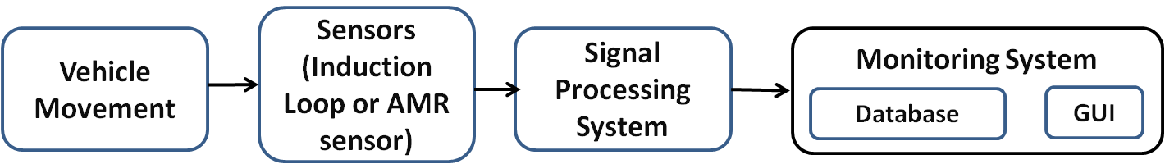

Fig 1: Block diagram of simple vehicle detection and monitoring system

The signal processing system processes the data from the sensors to eliminate any errors or false detections. Finally the traffic parameters acquired from the sensors are updated in a database and displayed using a GUI on the computer.

This project implements the induction loop as a means of acquiring vehicle count and classifying vehicles into two wheelers and four wheelers. The AMR sensors are used to acquire the count and speed of the vehicles.

# Hardware Description

## Induction Loop Detection System

The principal components of an inductive-loop detector system as shown in Fig.2 include:

* One or more turns of insulated loop wire wound in a shallow slot sawed in the pavement.
* Lead-in cable from the curbside pull box to the intersection controller cabinet.
* Electronics unit housed in a nearby controller cabinet.

Inductive-loop wire, lead-in wires, and lead-in cables typically use #12, #14, or #16 American Wire Gauge (AWG) wire. Here, a #12 AWG wire is used.

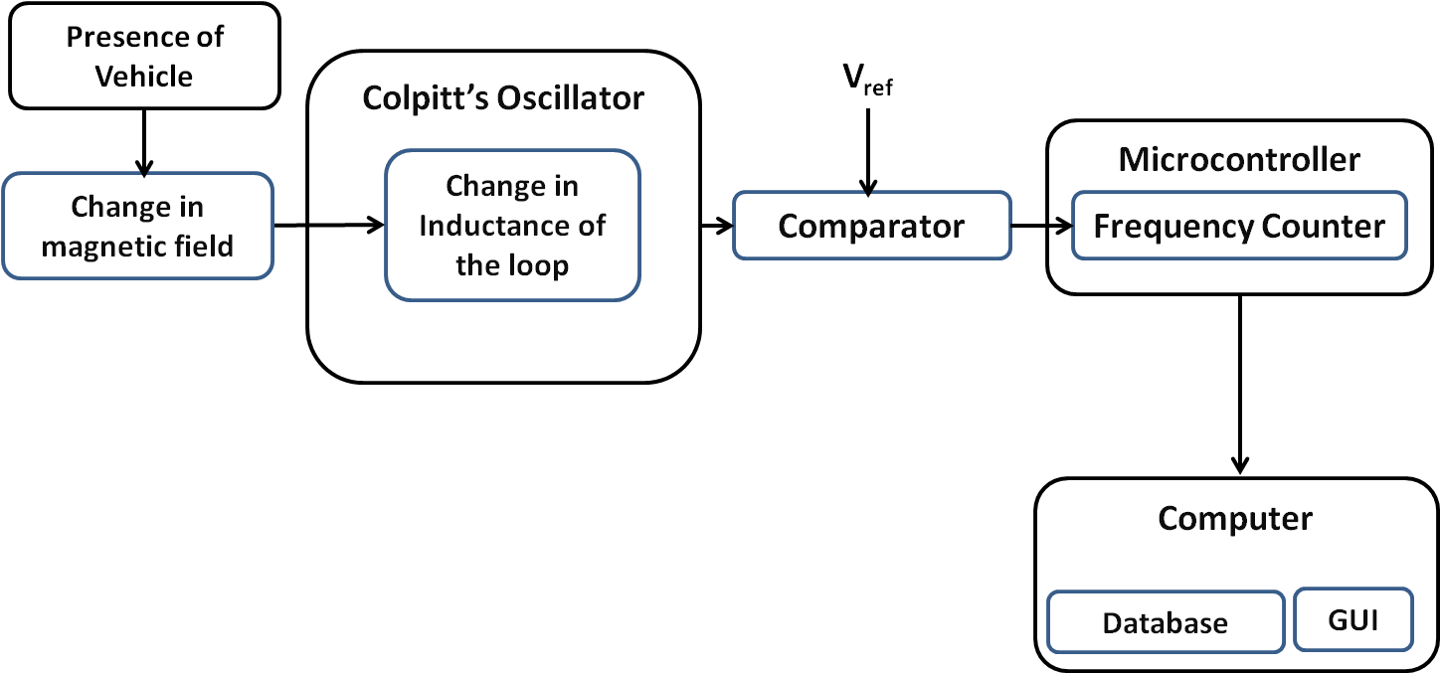

Fig 2: Block diagram of induction loop vehicle detection system

The electronics unit consists of a Colpitt’s oscillator, a comparator and a microcontroller. The inductive loop is a part of the tank circuit of the Colpitt’s oscillator. The oscillator and comparator are built with operational amplifiers. The microcontroller used here is ArduinoATmega2560- an ARM controller.

* 1. *AMR Vehicle Detection System*

The principle components of AMR vehicle detection system are:

* Anisotropic Magneto Resistive sensors: KMZ52.
* Microcontroller with transceiver: Jennic JN5148-001.
* 1.5V batteries.

The sensor contains two magneto-resistive Wheatstone bridges physically offset from one another by 90° and integrated compensation and set/reset coils.

The integrated compensation coils allow magnetic field measurement with current feedback loops to generate outputs that are independent of drift in sensitivity.

The JN5148-001 is an IEEE802.15.4 wireless microcontroller that provides a fully integrated solution for applications using the IEEE802.15.4 standard in the 2.4 - 2.5GHz ISM frequency band [1], including JenNet and ZigBee PRO.

The Wireless Transceiver comprises of 2.45GHz radio, a modem, a baseband controller which work together to provide IEEE802.15.4 Media Access Control (MAC) under the control of a protocol stack.

1. SOFTWARE DESCRIPTION

## Induction Loop Detection System

The Arduino integrated development environment (IDE) is used to write a program to measure the frequency drift due to vehicle movement. Signals from the comparator are square waves designed to have amplitude of 5V peak to peak, large enough to be detected by the microcontroller. These waves are fed to one of the input pins of the controller and are monitored.

The movement of vehicle over the loop produces a sinusoidal change in the magnetic field and hence a similar change is observed in the frequency of the oscillator. The concept of negative slope detection is used to detect the departure of vehicle which in effect determines the presence of vehicle and minimizes errors caused due to false counts.

The Arduino IDE supports all the features required for the implementation of this method and hence is used in this project.

* 1. *AMR Vehicle Detection System*

Cygwin is used to provide a Unix-like environment and command-line interface for Microsoft Windows. Cygwin consists of a library that implements the POSIX system call API in terms of Win32 system calls, a GNU development tool chain (including GCC and GDB) to allow software development, and a large number of application programs equivalent to those on Unix systems.

iShell is used for both wired and wireless programming of the iSense devices.

Eclipse is an integrated development environment (IDE) which is used to compile the c++ code written for vehicle detection.

A GUI was developed on Visual studio 2013 which displays speed and count.

# THEORY OF OPERATION

## Induction Loop Detection System

An induction loop detector provides a low cost method for detection of vehicles. The system consists of a loop of wire (typically 4 or 5 turns) buried approximately 20 mm below the road surface. The ends of the loop are returned to the vehicle detector usually housed some distance away in the controller cabinet.

The functioning of Inductive loop sensors is as follows. The inductive-loop is a part of the tank circuit of a Colpitt’s oscillator in which the loop wire and lead-in cable are the inductive elements. The comparator acts as an A/D convertor and converts the analog output signal of the oscillator into a square wave. This is fed to a microcontroller which continuously measures the frequency of the square wave input. When a vehicle passes over the loop or is stopped within the loop, the vehicle induces eddy currents in the wire loops, which decrease their inductance. The decreased inductance results in an increase in the frequency of the oscillator output. This increase in frequency is used by the microcontroller to detect the presence of vehicles.

The amount of eddy currents induced in the loop and thus the change in frequency depends on the mass of the ferromagnetic material in the proximity of the loop. Since two wheelers and four wheelers have different amounts of ferromagnetic material in them, the corresponding frequency change as they pass over the loop is also different. This difference is used by the microcontroller to classify the vehicles.

The traffic parameters i.e. the count and classification of vehicles is then sent by the microcontroller to a computer where they are displayed in the GUI and stored in a database. A flow chart for the functioning of the Induction loop detector system is shown in Fig 3.

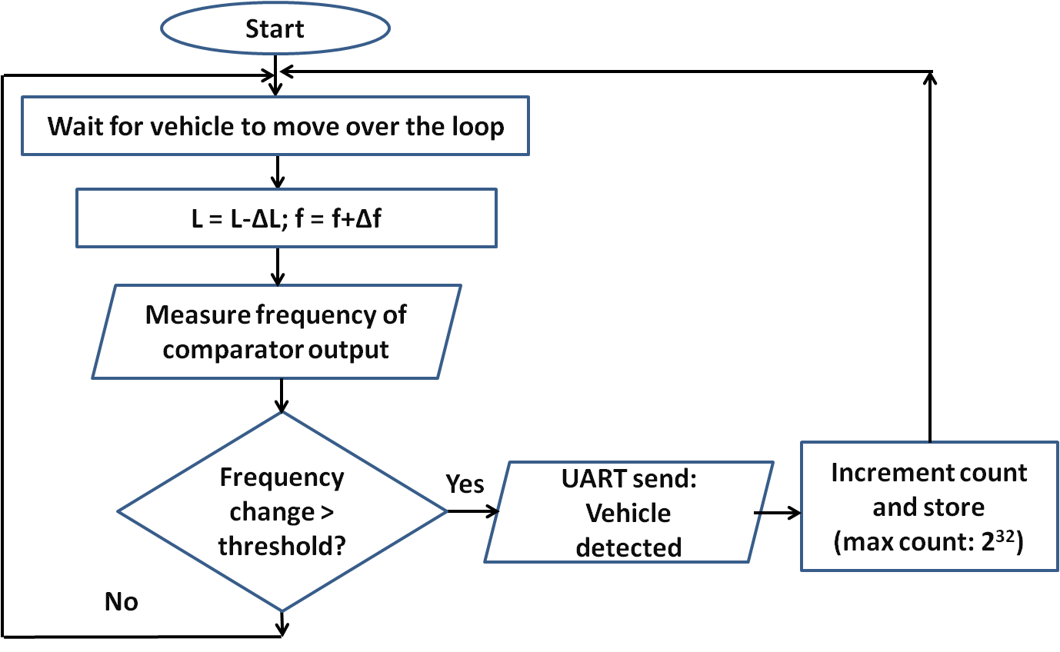

Fig 3: Flow chart for induction loop system

* 1. *AMR Vehicle Detection System*

An AMR sensor is a sensing device that utilizes the rate of change of magnetic resistance which is affected by the strength of the external magnetic field to detect the presence of vehicles.Magnetic sensors were introduced as an alternative to the inductive-loop detector for specific applications. A magnetic sensor is designed to detect the presence or passage of a vehicle by measuring the perturbation in the Earth’s quiescent magnetic field caused by a ferrous metal object (e.g., a vehicle) when it enters the detection zone of the sensor.

The block diagram of the AMR vehicle detection system is show in Fig 4. The system contains two slave modules that are buried along the length of the road with a distance of two meters between them. The slave modules consist of a two axis AMR sensor and a microcontroller interfaced with a ZigBee transceiver. The modules are used for speed calculation and communicate with a master module using ZigBee protocol. The master module consists of a microcontroller interfaced with a ZigBee transceiver and is connected to the computer through UART. The sensors on the slave modules detect the presence of vehicles and send a time stamp indicating the time at which the vehicle was detected to the master module. The difference in time indicated by the two time stamps is then used by the master module to calculate the speed using the following relation.

S = D/T

where,

S is the speed,

D is the distance between the two AMR sensors i.e. 2m,

T is the difference between the times indicated by the two time stamps.

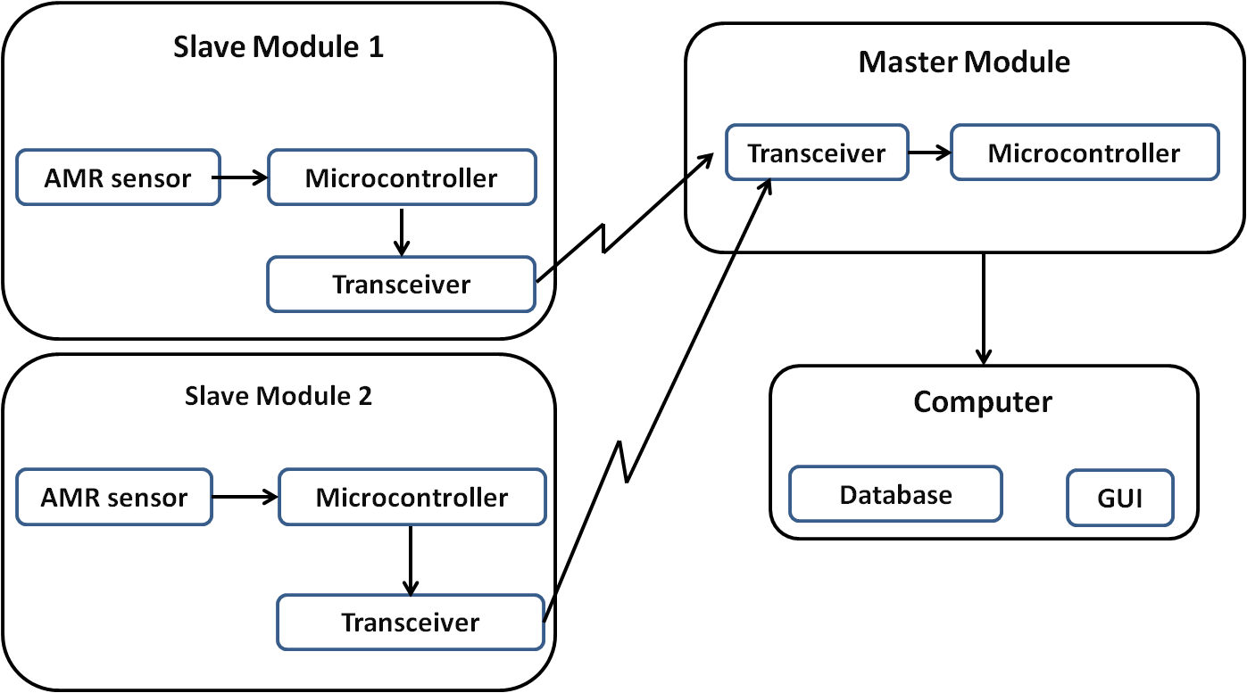

**Fig 4**: Block Diagram of AMR sensor Vehicle Detection System

The traffic parameters i.e. the count and speed of the vehicles is then sent by the microcontroller to a computer where they are displayed in the GUI and stored in a database.

A flow chart for the functioning of the slave and master modules is shown in Fig 5and 6 respectively.

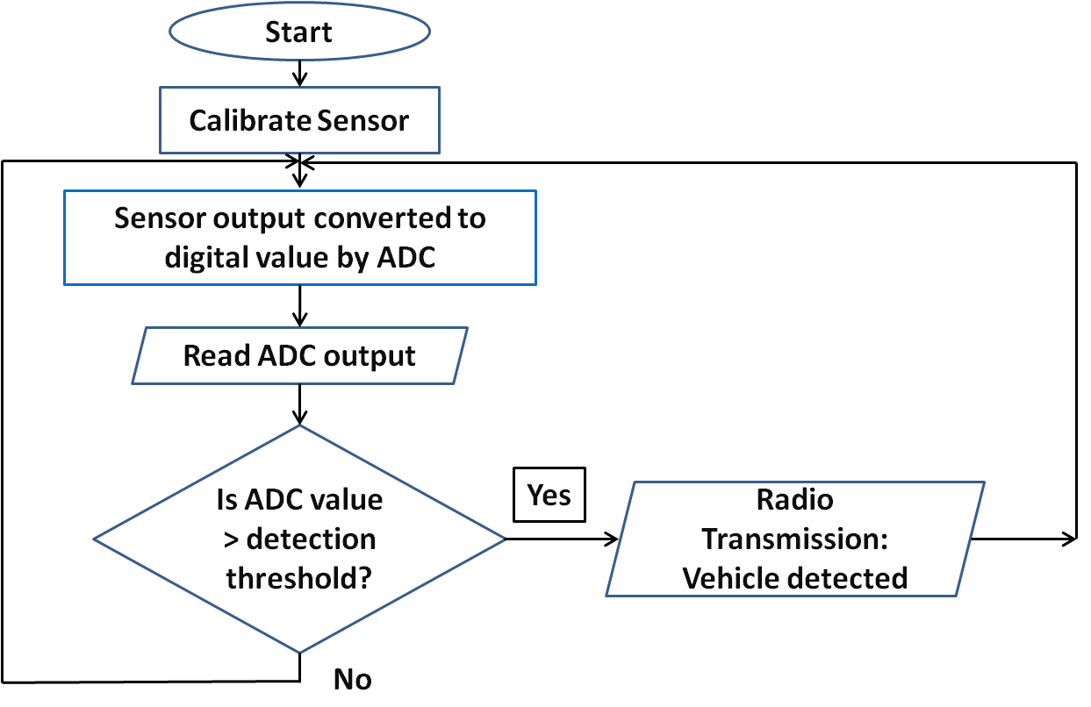

**Fig 5:** Flowchart for Slave Module

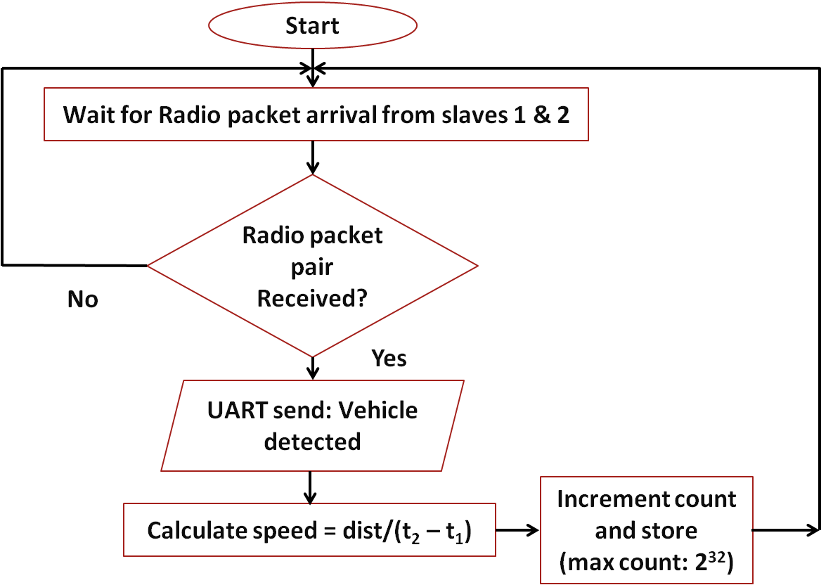

**Fig 6:**Flowchart for master module

# results

## Induction Loop Detection System

The typical output waveforms of the oscillator and the comparator are shown in Fig.7.

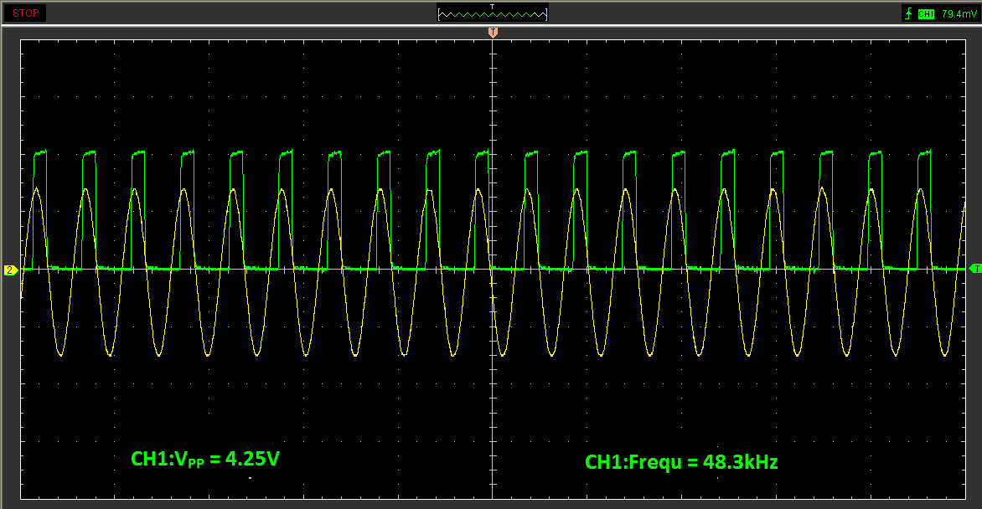Fig 7: **Collpitt’s oscillator and comparator output**

When the system is turned on, a high frequency counter sourced by a crystal oscillator is started on the microcontroller.

Whenever a rising edge occurs on the input capture pin, the counter value is recorded. The difference in consecutive captured counter values can be used to determine the time period and frequency of the input signal.

A decrease in the inductance of the loop occurs when a vehicle is positioned over it. This decrease causes a corresponding increase in the output frequency of the LC oscillator. This increase is sensed by the microcontroller that outputs a signal to the computer to indicate the presence of a vehicle. The amount of change in the inductance and hence the frequency is used to classify the vehicles as two wheelers and four wheelers.

The dimension of 6ft x 6ft was chosen since the average width of a passenger car and the average length of a two wheeler is 6ft. This is important since maximum frequency drift is observed when the dimension of the metallic object is

comparable to the dimension of the induction loop.

A snapshot of the induction loop detector system is shown in Fig 8.

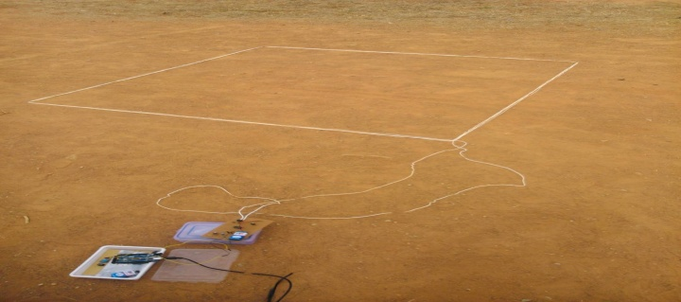

Fig 8: Snapshot of induction loop system

Table I shows the format of the database that stores the data about the count and class of vehicles acquired by the Induction Loop system.

# TABLE I. Database format for induction loop detector system

|  |  |  |  |
| --- | --- | --- | --- |
| *Date* | *Two wheeler Count* | *Four Wheeler count* | *Total count* |
| *30/04/2014* | *9* | *9* | *18* |
| *01/05/2014* | *5* | *6* | *11* |
| *02/05/2014* | *3* | *2* | *5* |

The induction loop system was tested to determine the frequency drifts for two wheelers and four wheelers at different speeds. Ten trials were carried out at each speed ranging from 10 to 40 for each type of vehicle. The results obtained are tabulated below (Table II and Table III).

# TABLE II. Frequency drift values for different speeds in case of two wheelers

|  |  |  |
| --- | --- | --- |
| **Speed (kmph)** | **Frequency drift range (Hz)** | **Avg. frequency drift(Hz)** |
| 10 | 870-1110 | 1010.8 |
| 20 | 764-1262 | 1006.2 |
| 30 | 688-1246 | 1000.2 |
| 40 | 746-1056 | 937.8 |

# TABLE III. Frequency drift values for different speeds in case of four wheelers

|  |  |  |
| --- | --- | --- |
| **Speed (kmph)** | **Frequency drift range (Hz)** | **Avg. frequency drift(Hz)** |
| 10 | 870-1110 | 1010.8 |
| 20 | 764-1262 | 1006.2 |
| 30 | 688-1246 | 1000.2 |
| 40 | 746-1056 | 937.8 |

Thus the frequency drift is found to decrease with speed in case of both two wheelers and four wheelers. This is due to the fact that the vehicle stays within the loop for a shorter duration of time as the speed increases. Thus the eddy currents induced in the loop is lower resulting in a smaller decrease in inductance. Hence the corresponding increase in frequency smaller results in smaller frequency drifts.

* **Accuracy of count**

No. of trials = 50

No. of times a vehicle went undetected or detected more than once = 4

**Accuracy = 92%**

* **Accuracy of classification**

No. of trials = 50

No. of times a two wheeler was detected as a four wheeler or vice versa = 5

**Accuracy = 90%**

1. *AMR Vehicle Detection System*

Figure 9 shows the experimental setup of the slave modules buried in the ground which were then covered by mud and vehicles were moved on them to observe the results.



**Fig.9** Experimental setup used to calculate speed in case of AMR vehicle detection system

The typical output waveform of an AMR sensor when a vehicle passes over it is as shown in Fig 10.

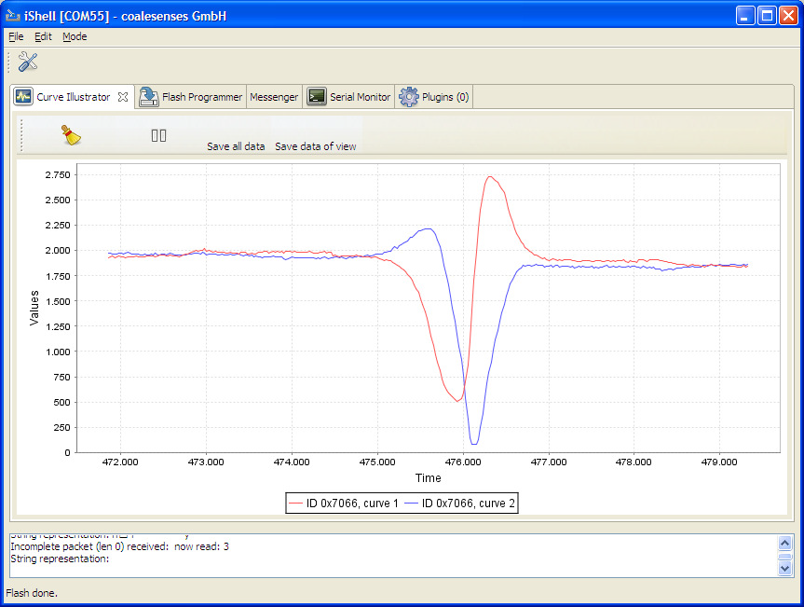

**Fig 10.** Typical output waveform of the AMR sensor. The red and the blue curves represent the output of the sensor in the two axes.

The system consists of two sensor modules which act as slaves and a core module which acts as a master. The slave modules communicate wirelessly with the master module via the ZigBee protocol. The master module is connected to a computer using a serial cable and communicates with it via UART. The computer is used to store the database and display it using a GUI.

The sensors on the slave modules detect the change in the ambient magnetic field. Initially they are calibrated to account for the magnetic field of the ambient environment and the default magnetic field generated by the earth. When a ferromagnetic material (commonly found in vehicles) passes over the sensor it disturbs the magnetic field around it. This change in magnetic field is detected by the sensor. It is observed that the output of the sensor peaks when a vehicle passes over it. These peaks are used to detect the presence of vehicles.

TABLE IV. DATABASE FORMAT FOR AMR VEHICLE DETECTION SYSTEM

|  |  |  |
| --- | --- | --- |
| Date | Vehicle count | Average speed (kmph) |
| 03/05/2014 | 8 | 22.92 |
| 04/05/2014 | 8 | 24.20 |

TABLE V. ACCURACY OF DETECTED SPEED

|  |  |  |  |
| --- | --- | --- | --- |
| Type of vehicle | Actual speed (kmph) | Detected speed(kmph) | Error (in %) |
| Two wheelers | 10 | 8.98 | 10.2 |
| 10 | 7.64 | 23.6 |
| 20 | 18.00 | 10.0 |
| 20 | 21.56 | 7.8 |
| 30 | 26.54 | 11.5 |
| 30 | 28.87 | 3.8 |
| 40 | 35.64 | 10.9 |
| 40 | 36.11 | 9.7 |
| Four wheelers | 10 | 10.58 | 5.8 |
| 10 | 12.00 | 20 |
| 20 | 18.23 | 8.8 |
| 20 | 20.57 | 2.8 |
| 30 | 27.91 | 7.0 |
| 30 | 30.35 | 1.2 |
| 40 | 37.22 | 6.9 |
| 40 | 36.78 | 8.1 |

The AMR sensor vehicle detection system was tested to determine the accuracy of the detected speed for two wheelers and four wheelers at different speeds. Eight trials were carried out for each type of vehicle. The results obtained are tabulated below

The actual error values may be lower than the mentioned values since the actual speed was observed on analog speedometers.

* **Accuracy of count**

No. of trials = 2

No. of times a vehicle went undetected or detected more than once = 1.

**Accuracy = 96%**

# VI.CONCLUSION

One of the advantages of Induction loop detector system over AMR sensor vehicle detection system is that the initial installation costs are much lower. They can also detect stopped vehicles. However, significant and reliable change in magnetic field occurs only when the vehicle is completely inside the loop, as against the AMR sensors which are more sensitive to the presence of magnetic materials.

Magnetic sensors are more economical compared to inductive loops as they are easy to reinstall and maintenance costs are low. Magnetic sensors are smaller in size compared to inductive loops which require a minimum area of around 36 sq. ft.

Magnetic sensors have proven to be more immune to noise and stable compared to frequency drifts occurring in the induction loop system due to environmental changes.

Devices embedded in asphalt often get damaged as a result of pressure exerted on the ground by heavy vehicles passing. Small sensors have therefore an advantage over those like large inductive loops, as their re-installation is associated with lower costs.

The sensing and measurement architecture of magnetic sensors uses a minimal level of energy and uses state-of-the-art low-power sensing, amplification, and communication technologies.

Thus magnetic sensor systems are more efficient and reliable than induction loops.

# FUTURE ENHANCEMENTS

1. *Induction Loop Detection System*

* Two loops can be used to determine the speed of the vehicles.
* Methods for solving the problem of detection of vehicles moving parallel to each other can be implemented.

1. *AMR Vehicle Detection System*

* Sensors with higher sampling rate can be used to classify vehicles based on their magnetic signature.

Auxiliary sensors such as video processing systems and infrared sensors can be used in conjunction with the induction loop and AMR sensor systems to eliminate false counts and increase the accuracy of the traffic parameters acquired.

# References

[1] Ravneet Bajwa, Ram Rajagopal, Pravin Varaiya and Robert Kavaler. “In-Pavement Wireless Sensor Network for Vehicle Classification”. Sensys Networks, Inc, 2560 Ninth Street, Suite 219, Berkeley CA 94710

[2] Sing Yiu Cheung, Sinem Coleri Ergen and Pravin Varaiya. “Traffic Surveillance with Wireless Magnetic Sensors”.

[3] Farshad Ahdi, Mehdi Kalantari Khandani, Masoud Hamedi, Ali Haghani. “Traffic data collection and anonymous vehicle detection using wireless sensor networks”.

[4] Traffic Detector Handbook: Third Edition—Volume I. Publication No. FHWA-HRT-06-108.

[5] D. Cebon. Handbook of Vehicle-Road Interaction.

Swets and Zeitlinger Publishers, 1999.

[6] Sun C. (2004). An investigation in the use of inductive loop signatures for vehicle classification. California PATH Research Report UCB-ITS-PRR-2002-4.

[7] Zhang, X., Y. Wang, N.L. Nihan (2004). Monitoring a freeway network in real-time using single-loop detectors: System design and implementation, 83rd TRB Annual Meeting, Washington, D.C.

[8] Ding, J (2003). Vehicle detection by sensor network nodes. MS thesis, Department of Electrical Engineering and Computer Science, University of California, Berkeley, CA.

[9] Oh, S., S.G. Ritchie, C (2002). Oh. Real time traffic measurement from single loop inductive signatures, 81st TRB Annual Meeting, Washington, D.C.

[11] G.S.M. Galandanci & K.O. Ewansiha. Design and simulation of a 20 khz to 50 khz variable frequency oscillator (vfo). [www.arpapress.com/](http://www.arpapress.com/) Volumes/ Vol16Issue1/ IJRRAS_16_1_04.pdf

[12] Gordon, R.L., R.A. Reiss, H. Haenel, E.R. Case, R.L. French, A. Mohaddes, and R. Wolcott; Traffic Control Systems Handbook, FHWA-SA-95-032, Federal Highway Administration, U.S. Department of Transportation, Washington, D.C., Feb. 1996

[13] Seri Oh, Stephen G. Ritchie, and Cheol Oh. Real Time Traffic Measurement From Single Loop Inductive Signatures, presented for 81st Annual Meeting of the Transportation Research board, Washington D.C., January 2002.

[14] Chao Chen, Jaimyoung Kwon, John Rice, Alexander Skabardonis and Pravin Varaiya. Detecting Errors and Imputing Missing Data for Single Loop Surveillance Systems, Presented in the 82nd Transportation Research Board Annual Meeting, Washington D.C., January 2003.

[15] Luz Elena Y. Mimbela and Lawrence A. Klein. A Summary of Vehicle Detection and Surveillance Technologies used in Intelligent Transportation Systems, the Vehicle Detector Clearinghouse, New Mexico State University, Fall 2000.

[16] Sun, C., S.G. Ritchie, and K. Tsai. Algorithm Development for Derivation of Section-Related Measures of Traffic System Performance using Inductive Loop Detectors. In Transportation Research Record 1643, TRB, National Research Council, Washington, D.C., 1998, pp. 171-180.

[17] Marcin Bugdol, Zuzanna Segiet, Michal Krecichwost, Pawel KASPEREK,Vehicle Detection System Using Magnetic Sensors,Transport Problems 2014 Volume 9 Issue 1

[18] Ripka, P. Magnetic Sensors and Magnetometers. Norwood: Artech House. 2001.

[19] Texas Transportation Institute. Alternative Vehicle Detection Technologies for Traffic Signal

Systems: Technical Report. Austin. 2008.

[20] Tumański, S. Thin Film Magnetoresistive Sensors. London: IOP Publ. 2001.